APPLICATION FORM FOR INTERNATIONAL STUDENTS
(MASTER’S DEGREE PROGRAMS)
国际学生硕士项目入学申请表
个人基本信息Basic Information
姓名  Full Name | 姓Surname |  |  |  |  |  |  |  |  |  |  |  |  | 照片  Photo
 | 名Given Name
 | 中文名In Chinese
国籍  Nationality |  |  |  |  | 性别  Gender |  |  |  | □男Male
 |  |  |  |  |  |  |  |  | □女Female
出生日期  Date of Birth | /年YY /月MM /日DD |  |  |  |  |  |  |  |  |  | 出生地  Place of Birth
最高学历  Degree Obtained |  |  |  |  |  |  |  |  |  |  | 婚姻状况  Marital Status |  |  | □已婚Married
 |  |  |  |  |  |  |  |  |  |  |  |  |  | □单身Single
健康状况  Health Condition | □ 良好In good health  □ 不太好，原因Not in good health with issue(s) of___________________
宗教信仰  Religion |  |  |  |  |  |  |  |  | 母语  First Language
电子邮箱  E-mail |  |  |  |  |  |  |  |  | 联系电话  Tel
英语能力  English Proficiency | □ 母语Native  □ 流利Proficient  □ 高级Advanced  □ 良好Conversational  □ 初级Basic  □ 不会None |  |  |  |  | 考试和分数Test(s) taken  TOEFL (score) ____.  IELTS (score) ____.  Others (score) ____.
汉语能力  Chinese Proficiency | □ 母语Native  □ 流利Proficient  □ 高级Advanced  □ 良好Conversational  □ 初级Basic  □ 不会None |  |  |  |  | 考试级别和分数Test(s) taken  HSK(level/score) ____.  Others(level/score) ____.
专业选择  Majors you apply for | 第一志愿（No.1）  第二志愿（No.2）  是否服从调剂/ Accept other majors or not? □是/Yes □否/No
宿舍Accommodation |  |  |  | □ 校内住宿On Campus □ 校外住宿Off Campus
经济来源Source of Funding |  |  |  | □ 奖学金Scholarship □ 自费Self-Supporting
教育背景Education Background
(从高中到最高学历From high school to the highest degree)
起止时间  Duration (from - to) |  | 学校/学院  Institute |  |  |  |  |  | 主修专业  Fields of study |  |  |  | 所获文凭  Diploma or Certificate
-
-
-
工作经历Work Experience (如有if any)
起止时间  Duration (from - to) |  | 就职单位  Name of Employer |  |  |  |  |  |  |  |  |  | 职务  Position
-
-
所获奖励Awards(如有if any)
年份Year |  | 奖项名称Name of the Award |  |  |  |  |  |  |  |  |  | 授予单位  Name of Awarding Unit
须提供的其他信息Supplementary Information Required
永久通讯地址  Permanent Address |  | 街道和门牌Street________________  城市City_________________  国家Country______________  邮编Postcode_________________  住宅电话或移动电话Home Tel/Mobile __________________
邮件地址  Mailing Address |  | 街道和门牌Street________________  城市City_________________  国家Country______________  邮编Postcode_________________  住宅电话或移动电话Home Tel/Mobile __________________
家庭成员Family Members
姓名Name |  |  | 关系 Relationship |  |  |  |  |  |  | 职业  Occupation |  |  | 电话Tel
紧急联系人Emergency Contact
姓名Name |  |  | 关系Relationship |  |  |  |  |  |  | 电话Tel |  |  | 电子邮件E-mail
有无过往犯罪或违规记录，如有，请说明Please clarify if any illegal or criminal record(s) |  |  |  |  |  |  | □ None  □ Yes____________________________.
申请人保证：
- 上述各项中所提供的情况是真实无误的；
- 在中国学习期间遵守中国政府的法律和学校的规章制度，尊重学校的教学安排。
- 在中国学习期间的任何意外或经济问题责任由本人承担。
I hereby affirm that:
- All the information given in this form is true and correct.
- I shall abide by the laws of the Chinese Government and the regulations of the school.
- I will take the responsibilities for any incidents or financial problems during my study in China.

个人签名Signature： 日期Date: YY MM DD
The application is invalid without signature.无此签名，申请无效。
注Note:  更多信息请关注For further information： https://cie.sues.edu.cn/  联系我们Please contact us：  电话by Tel:  +86-21-61175964；+86-21-61175974  电子邮件by E-mail:  cie@sues.edu.cn; studyatsues@qq.com  微信by Wechat:  请扫描右侧二维码scan the QR Code on the right |  |  |  |  |  |  |  |  |  | 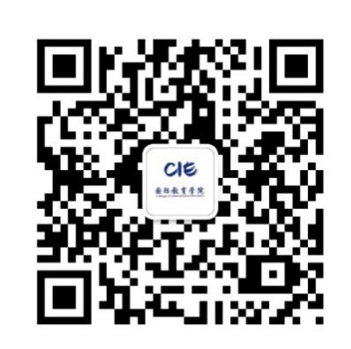  Please follow CIE Wechat  请关注CIE微信公众号

